SOA Developer Domain
Step 1 : Move to /home/{your_user_name_folder}/Oracle/Middleware/Oracle_SOA1/common/bin

Step 2 : Execute Command
sudo ./config.sh

Step 3 : Select Create a new Weblogic domain and click Next

Step 4 : Select The Appropriate Options
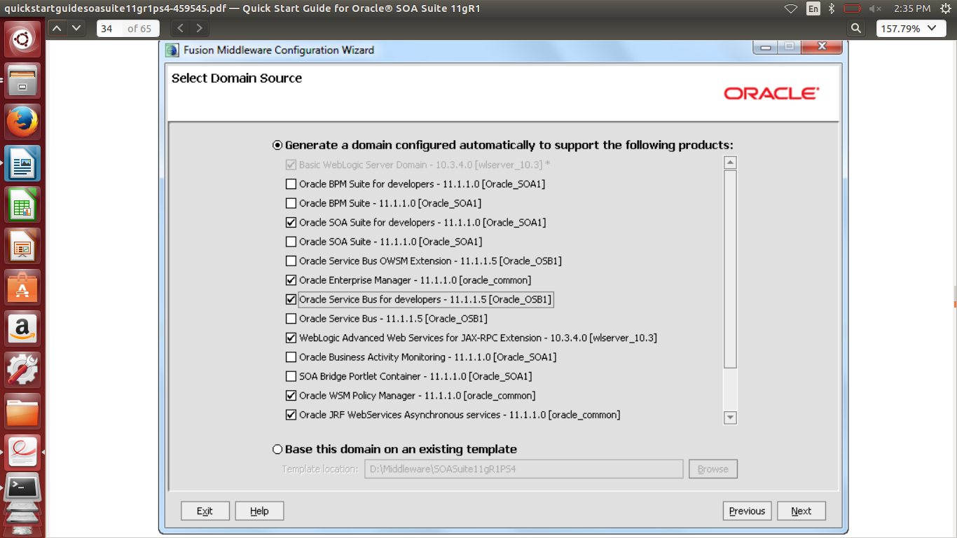
Step 5 : Click Next

Step 6 : Domain Name : SOAOSBPS4DevDomain
Domain Location : Keep it default
Application Location : Keep it default

Step 7 : Click Next

Step 8 : Name : weblogic
user password : admin123
confirm password : admin123
Description : Leave it As Default

Step 9 : Click Next

Step 10 : Select the Sun SDK and leave Development Mode checked

Step 11 : Click Next

Step 12 : Configure JDBC Component Schema screen
Select All checkbox and then
-> Schema Password : admin123
-> DBMS/Service : XE
-> Host Name : localhost
-> port : 1521

Now Deselect All Checkbox and then Next

Step 13 : Click Next

Step 14 : Click Next

Step 15 : Click Create

Step 16 : Click Done

Now it SOA Developer Domain is done now install JDK For Jdeveloper support

